**The final project of programming:**

**Dots and boxes:**

1. **Abdelrahman Ashraf Elmeniawy 18012538**
2. **Mohamed Mostafa Badran 18011621**
3. **Yousef Hassan Ibrahim 18012114**

**\*description of the game :**

Dots and Boxes is a game for two players (or more). It was ﬁrst published in the 19th century by Edouard Lucas, who called it originally la pipopipette. Starting with an empty grid of dots, two players take turns adding a single horizontal or vertical line between two unjoined adjacent dots. The player who completes the fourth side of a 1x1 box (or groups of one or more adjacent boxes) earns one point (s) and takes another turn. In this project we made our own version of the game.

**\*the feature of the application:**

-player vs player mode

-player vs computer mode (with a hard to win AI)

-different game modes easy, medium, hard and extreme

-Timer to show time passed since the game started which is updated after each move played

-Save and load (3 files available to save in)

-File containing all user who played the game with their score

-redo and undo moves played

**\*Design Overview:**

The game starts with a main menu containing the following options:

*Play a new game.

*Load a saved game.

*display the top ten.

*exit the game.

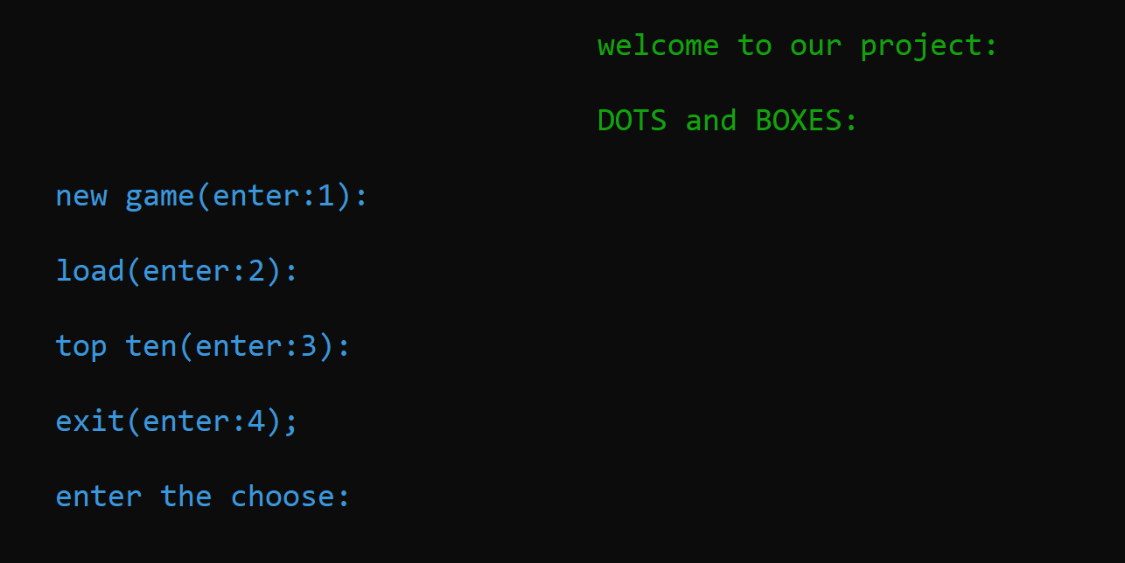

*if the user chose to start a new game:

- I ask him to determine the number of boxes in (1,3,5 or 8).

*next I ask him if he wants to play human vs human mode

Or human vs computer mode.

*then the user enter the names of the players.



*Then the game starts .

A footage of the game between a player (ahmed) and computer.

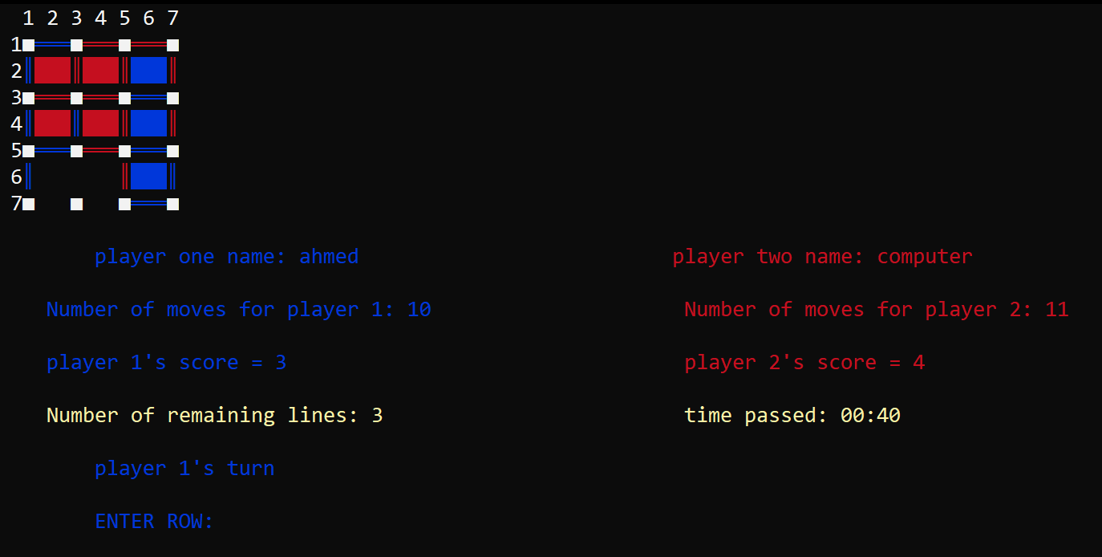

*If he chose to load game:

The user must choose a file to load from one of the three



if he choose an empty file or entered a wrong number the game give tell him the(number he entered) is not existing file and give choose to return to main menu or to exit

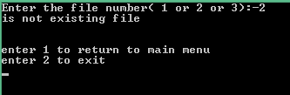

*if the user choose top ten the user will find the names of the users with highest scores and their score and to return to main menu he must press enter.

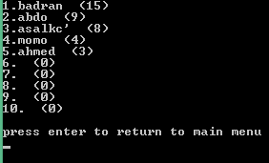

**\*Assumptions:**

To the user play the game we assumed the user read the game manual and know hexadecimal numbers.

**\*Data Structure:**

**structures:**

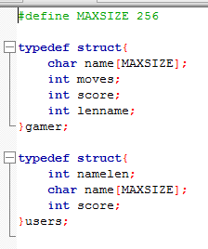

we have built two structs:

one called gamer which help us in the game to carry in game user data as name and in game score and number of moves played.

the other is called users which help us after the game and in displayed top ten to save the data of the user in outside file which contain his name and his name length (help in printing it) and his highest score.

**Arrays:**

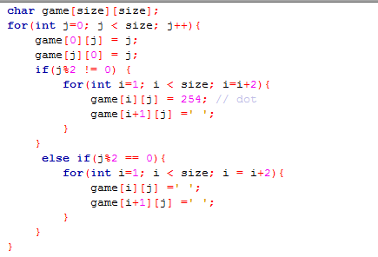

**Game array**: the array which contain the grid with the dots and lines played whenever a user or computer plays choose an available line the game array is updated and whenever a box is made the game array is also updated.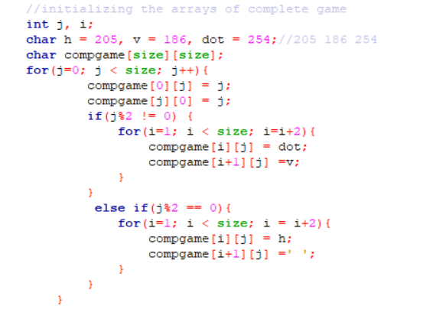

**complete game array**: the array which contain the grid with the dots and all possible lines can be played to help in identifies the right moves and complete boxes.

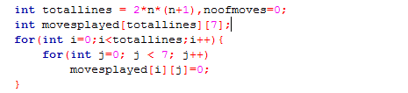

**Moves played array**: the array which contain all moves played with all details as the order of moves played and the user who played and the column and row of the move played and if this move complete box or not at the start of the game is array is set to zeros and after each move it is updated, it’s size is the number of total line available to play and 7(which will carry all the details of the line played).

**\*Functions:**

(1)function to scan integers :

This function is used instead of scanf to avoid errors when user enter character or any symbol this function store the user input in an array with size (MAXSIZE = 256) and will transfer the user input from char to int by comparing the value of each element in the array if the element is from (0 to 9) ascii code from 47 to 58 we get the value of ascii – 47 to get the required value and if the elements is from a to f ascii code (96 to 103) we get the value of ascii – 87 to get the required value.

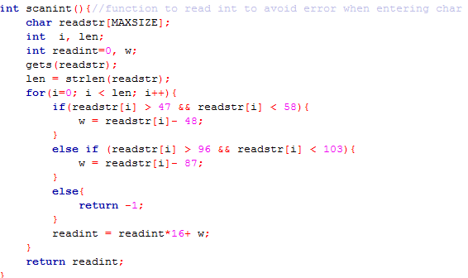

(2)function to print the game.

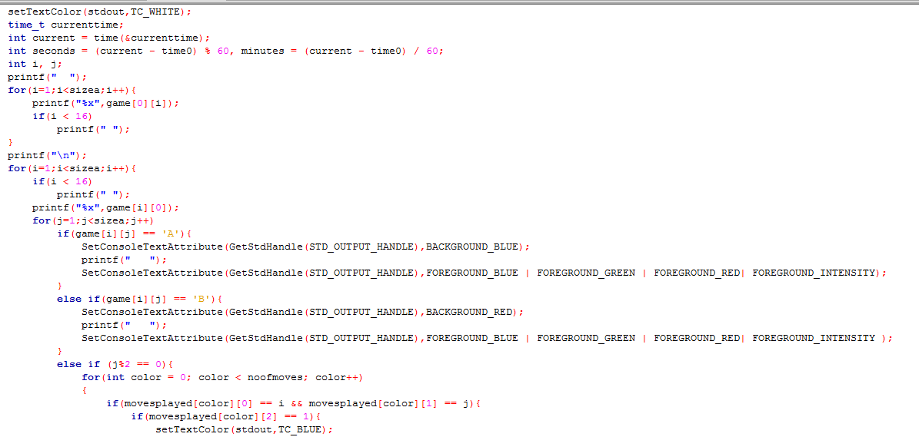

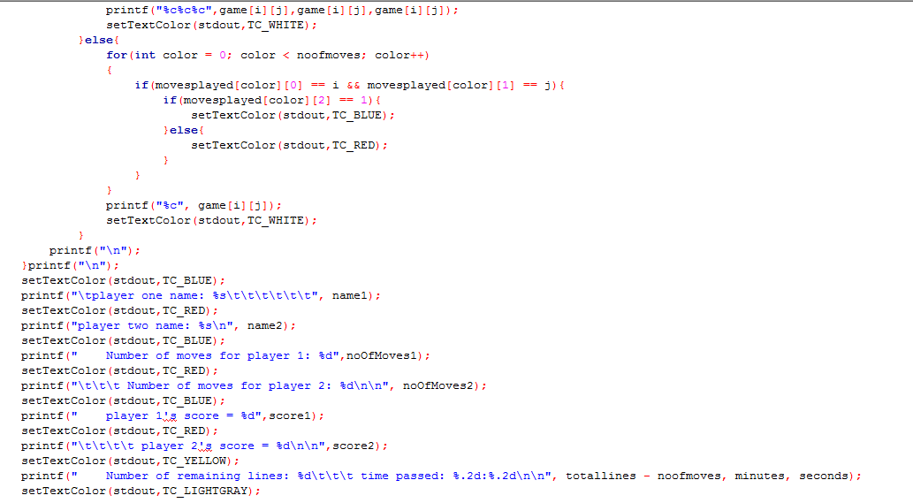Function used to print the game after each input of the user with colors of lines and boxes

(3)function to check if the player have score point or not called (check box).

Function used to check after each line played if the line played will make a box completed.If player entered an even number in row this is the code of check it will be vertical line. We check the box in the right and lift if it was closed or not. but If he entered an oddnumber in row this is the code of check it will be horizontal line. We check the box up and down if it was closed or not .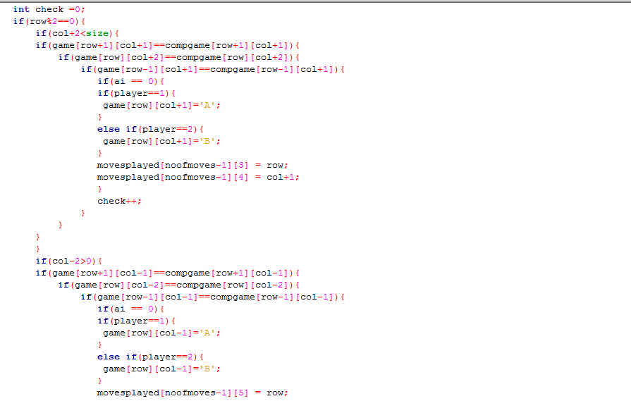

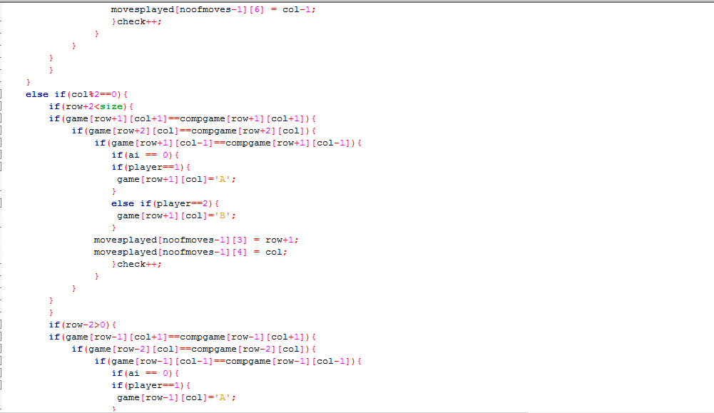

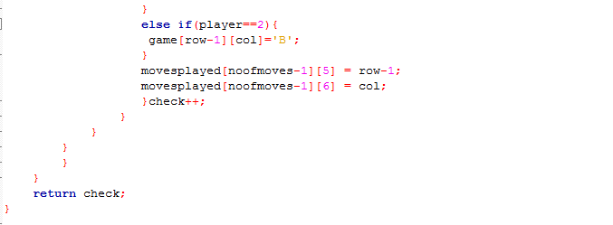

(4)function to run the game called (game function)

Function of the game, runs the game in all mode player vs player or player vs computer and when user saves or load and show time

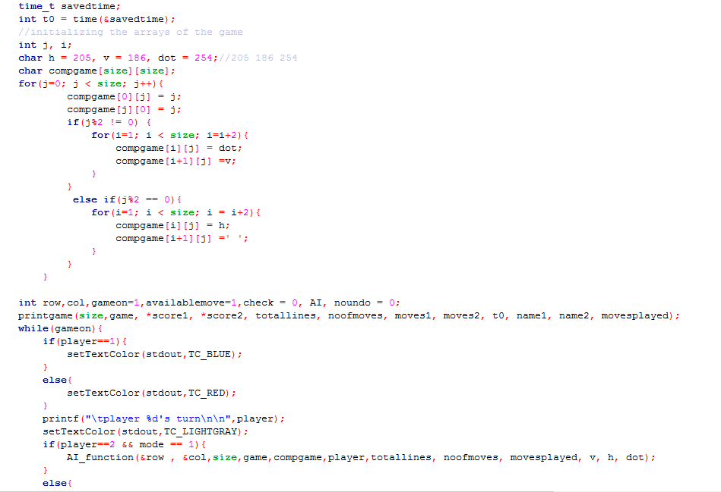

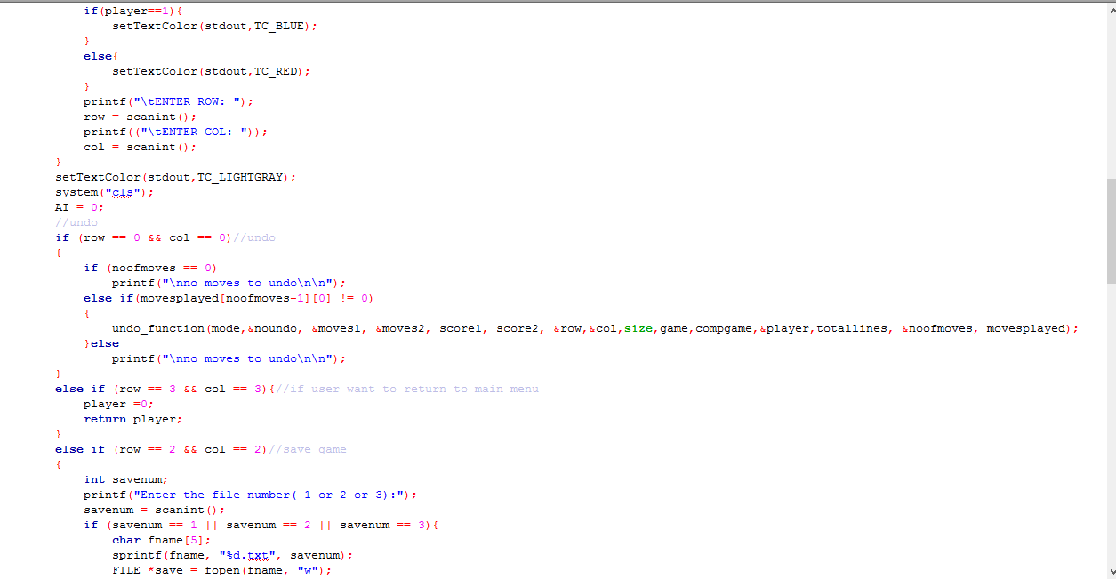

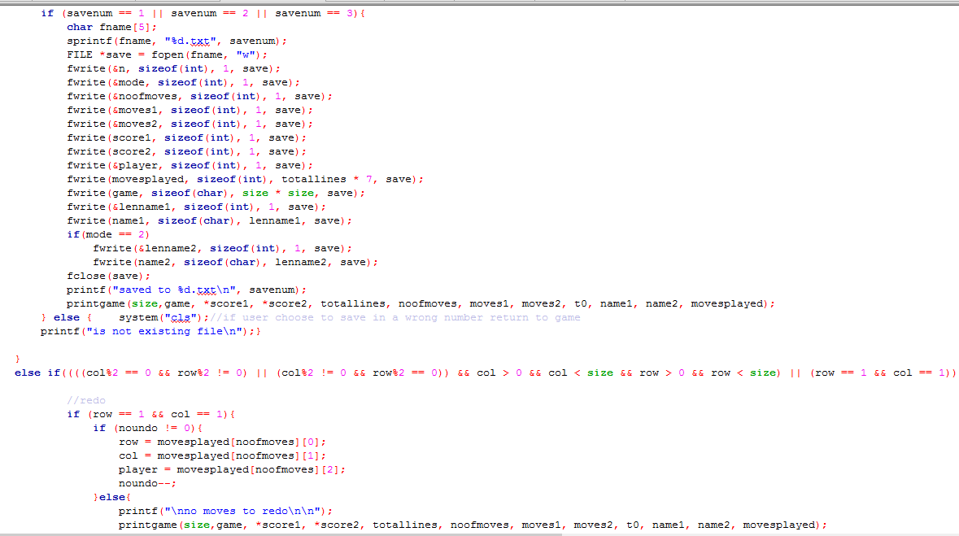

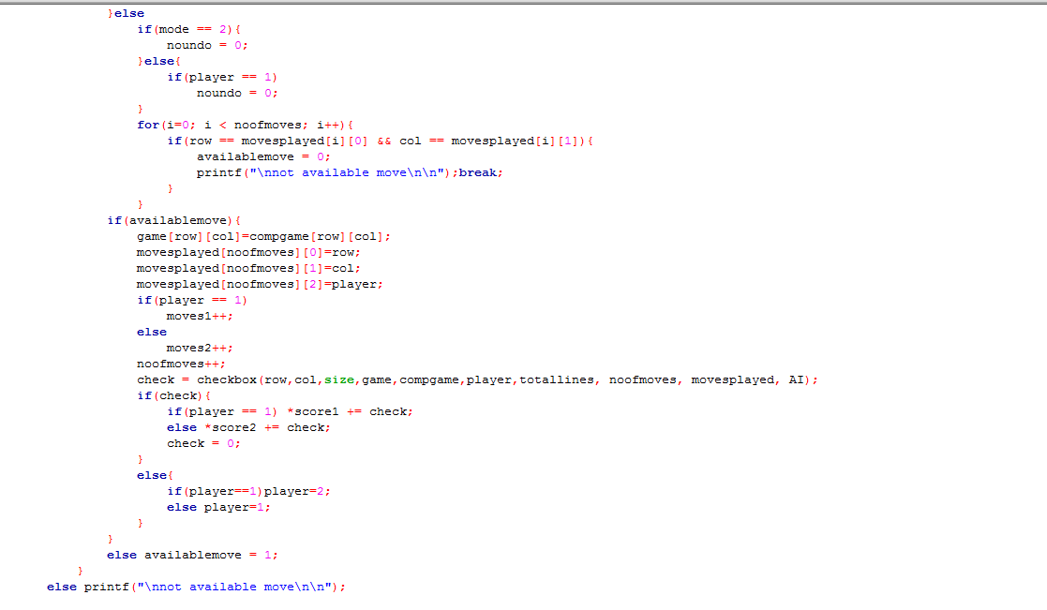

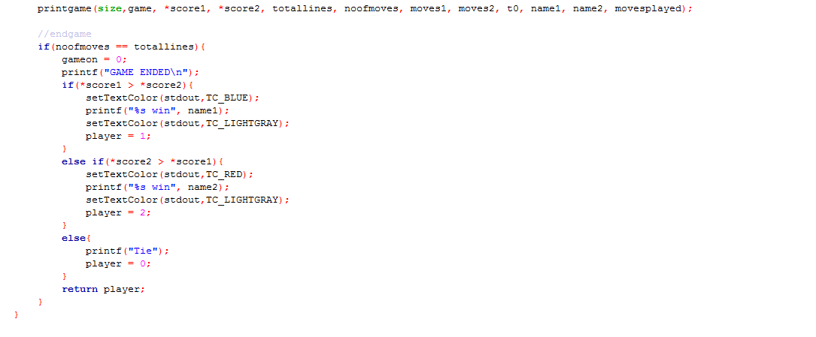

(5) sorting function to sort the users according to their score

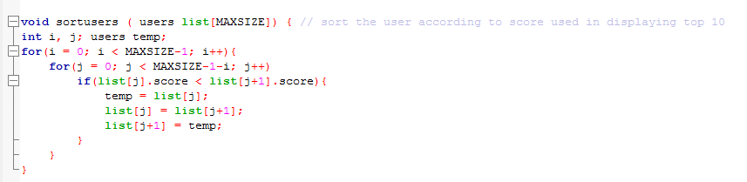

Function used in displaying top 10 as it arrange all the user in the file according to their rank. we used bubble sorting but in descending way.

(6)( AI_function).

we made the computer to choose the first place is empty that he checks by check box if he wins and still do it until the array is finished. if it won’t win it will choose the first place is empty then it will play another turn and check if the player will win he should choose another place. if there are only places that will make the player win so he will choose the first empty line.

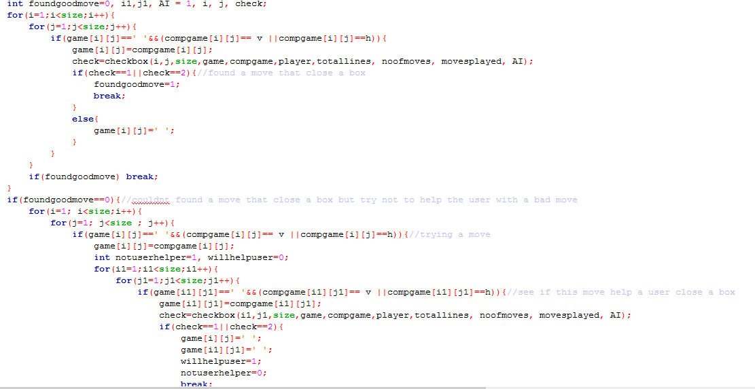

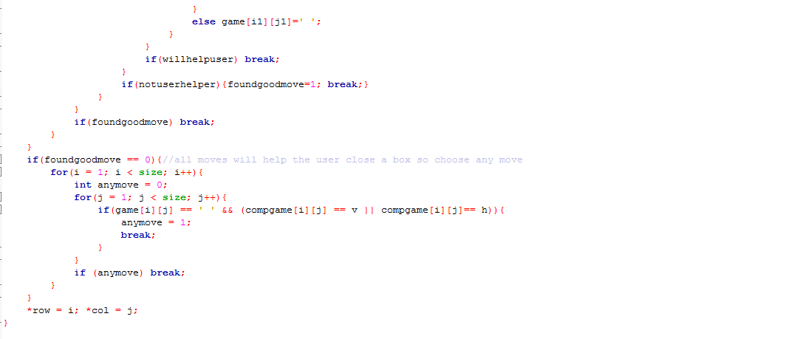

(6)undo

Used when user want to undo a move played using movesplayed array it also prepares if user want to redo in the future. in two players mode it make undo for only one move but in one player mode it makes undo until the last player one’s move.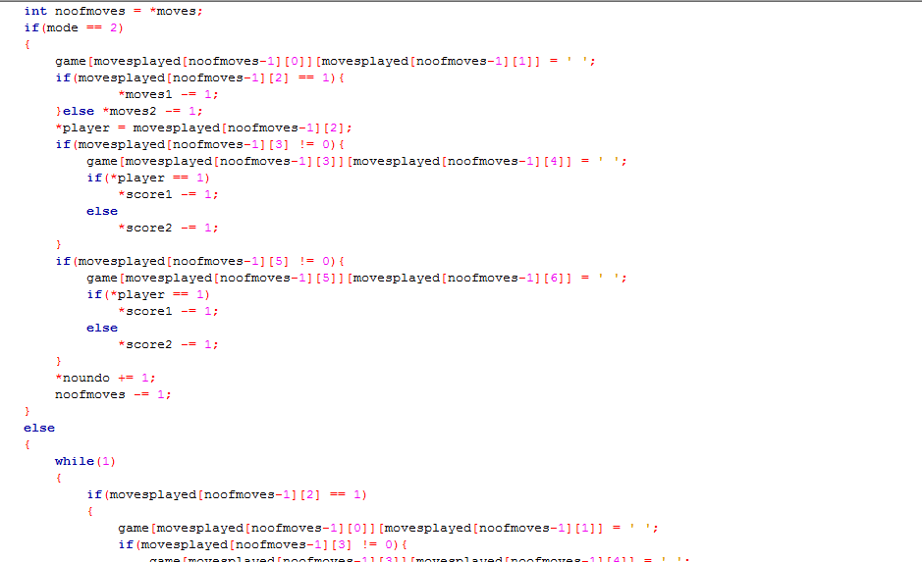

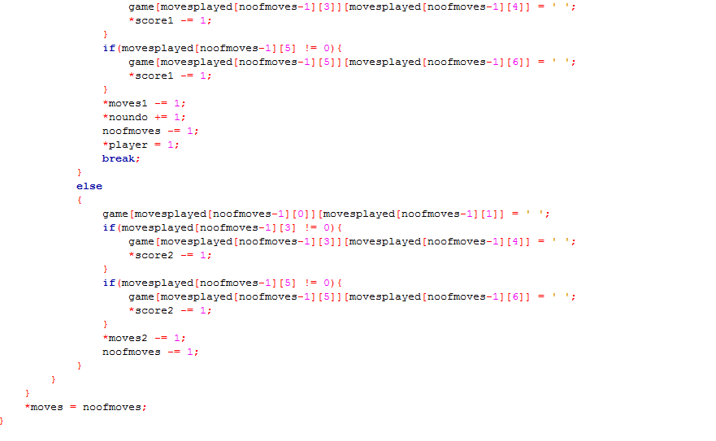

**\*Headers:**

We created 7 header where we split the functions between

**1-main.c**

Containing the interface and the main menu it wait for user input to see what to start (a new game or saved game) or display top 10 or exit and accordingly it uses functions from the other headers

**2-struct.h**

Containing the two structs made

**3-game_function.h**

Containing game function and sort users function

**4-undo_function.h**

Containing the undo function

**5-printgame.h**

Containing the print game function

**6-checkbox.h**

Containing check box function

**7-AI_function.h**

Containing AI function

**\*Flowchart:**

**Main menu:**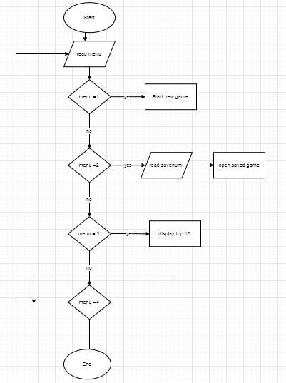

Player turn:

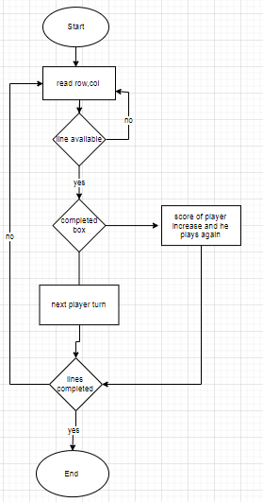

Check box:

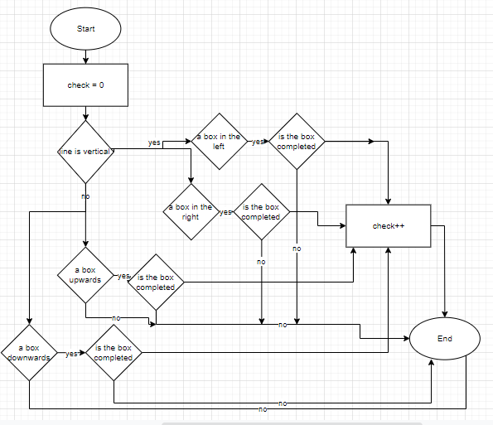

AI algorithm:

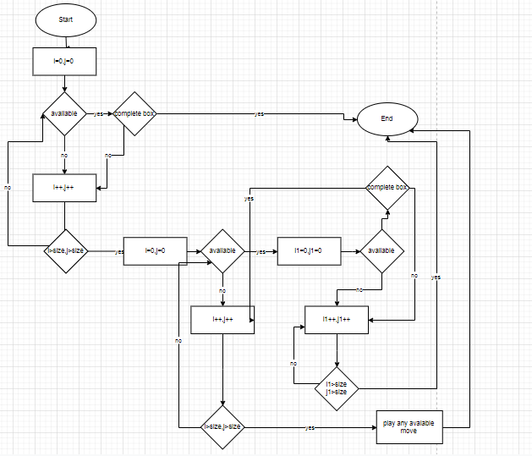

**\*user manual**



**if player choose one form main menu:**

now he will start a new game but he must enter the degree of difficulty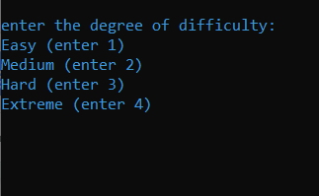

easy → 2 * 2 grid medium → 3 * 3 grid

hard → 5 * 5 grid extreme → 8 * 8 grid

if you choose the wrong number, this message will appear(error (invalid number)) and you can enter another number.

then you will choose the mode one player vs computer or two players 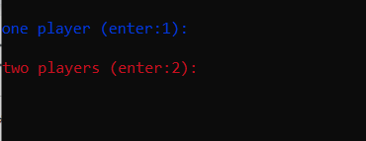

any other input this message will appear(please enter 1 or 2)

then you must enter your names 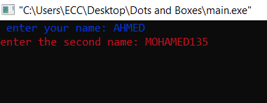

this screen will appear it has the empty grid and name of each player, his number of moves, his score and the number of lines remain and the time passed and whos the turn is. you should enter the coordinates of line wanted row first then column in hexadecimal digits. you can enter 0, 0 for undo the last move or 1, 1 to redo or 2, 2 to save the game or 3, 3 to go to the main menu or exit .

the color of player one is Blue.

the color of player two is Red.

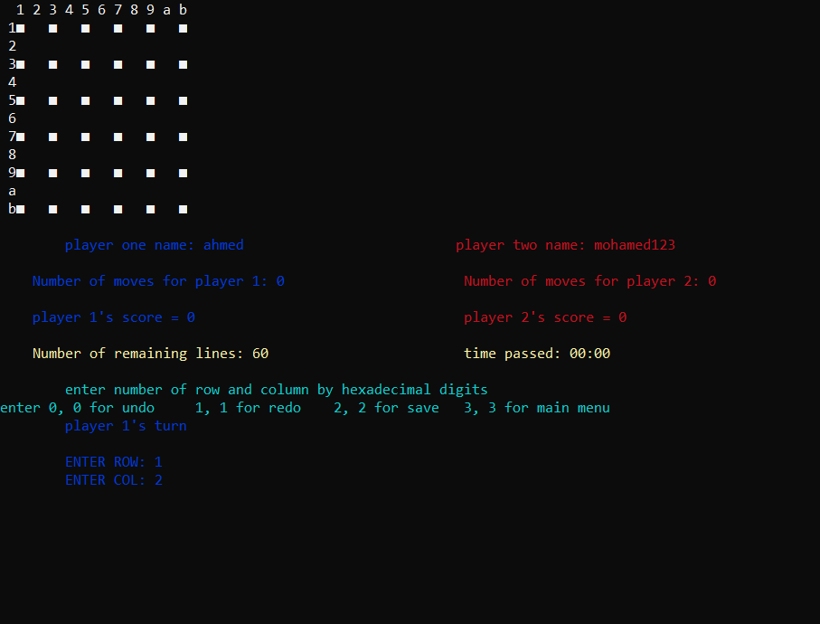

**if player choose two form main menu:**

you can load previous game but you have only 3 files that you can save or load if the file does not exist or is an empty file you will get warning message.

**if player choose three form main menu:**

He will get top ten players and their scores if the users file does not exist or is an empty file you will get empty rank with warning message.

**if player choose four form main menu:**

you will exit the game and if you choose any other number you will get warning message and you can enter number again